DYNAMODB

It is a serverless nosql database.

**THE TRADITINAL ARCHITECTURE**

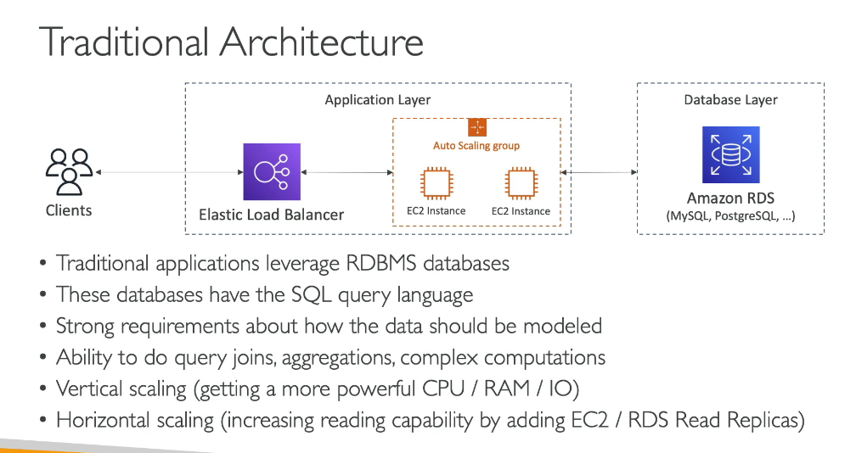

**INTRODUCTION TO NOSQL DATABASE**

By horizontal scaling we mean that we can increase the number of io just by increasing the number of ec2 instances.

Amazon dynamdb is a fully managed highly available with replication across multi az.It is a nosql database hence it is not a relational database.

DYNAMODB PRIMARY KEYS

There may be a case where you want that a user must be allowed to play some games,so for each user there will be a partition key which will uniquely identify a user and then there is a game id which is a sort key and the combination of both of these will be forming a primary key so no matter if there is a case where we have same partition key for a different game id since a user can play multiple games.

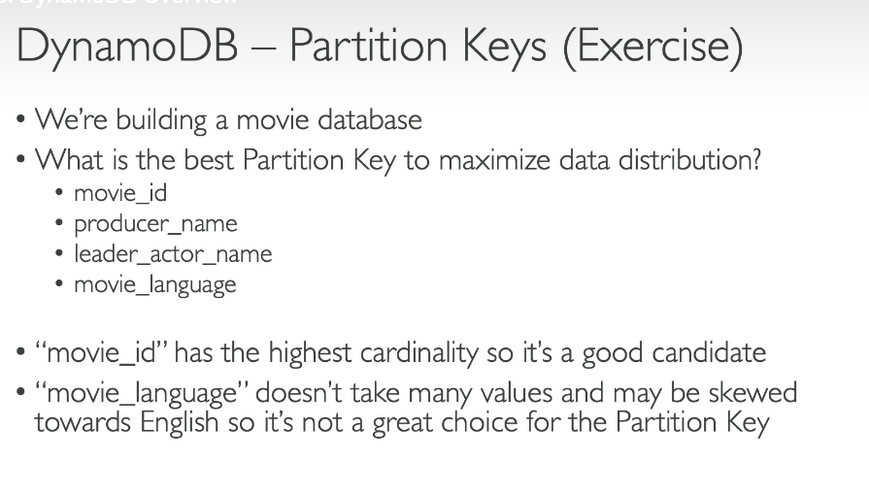

**DYNAMODB-READ/WRITE CAPACITY MODES**

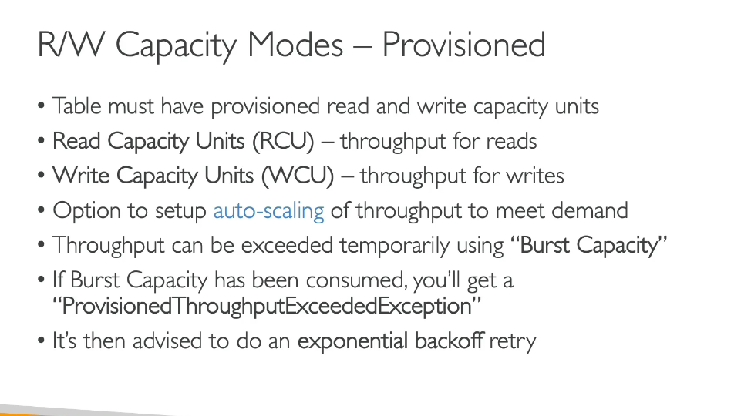

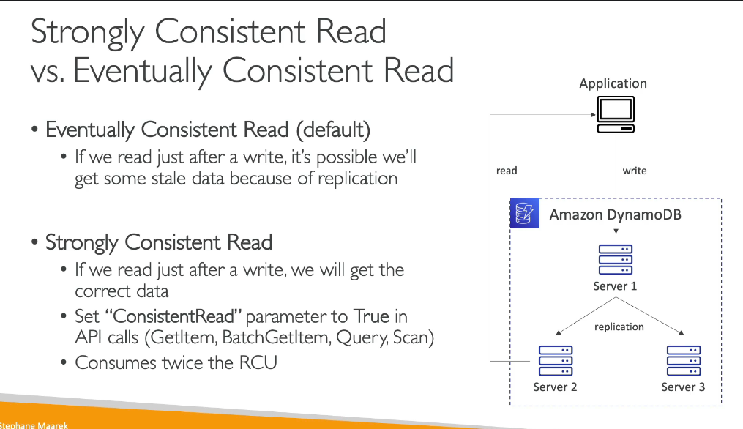

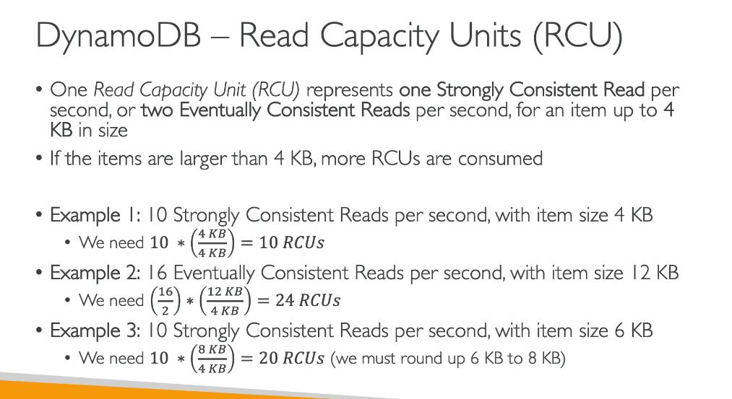**\**

**PARTITION INTERNALS**

**\*wcu and rcu divided separately**

**THROTTLING**

**DYNAMODB BASIC APIS**

**LOCAL SECONDARY INDEX**

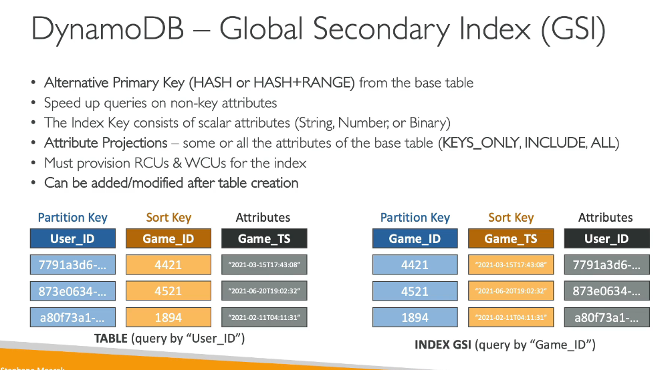

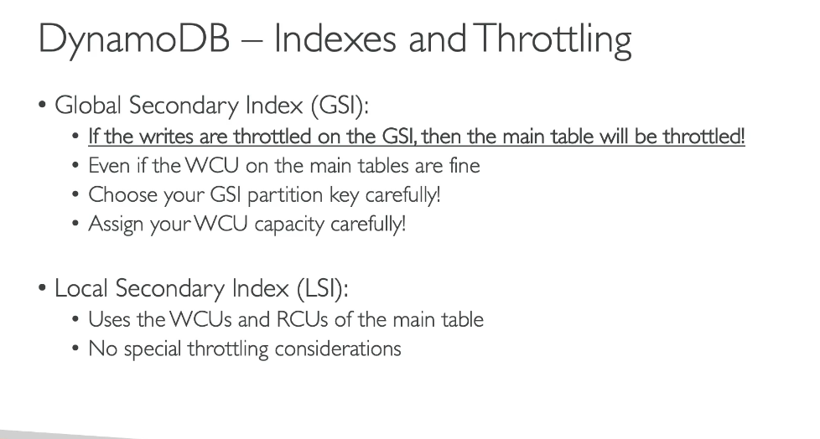

**DYNAMODB STREAMS**



